**HTML**



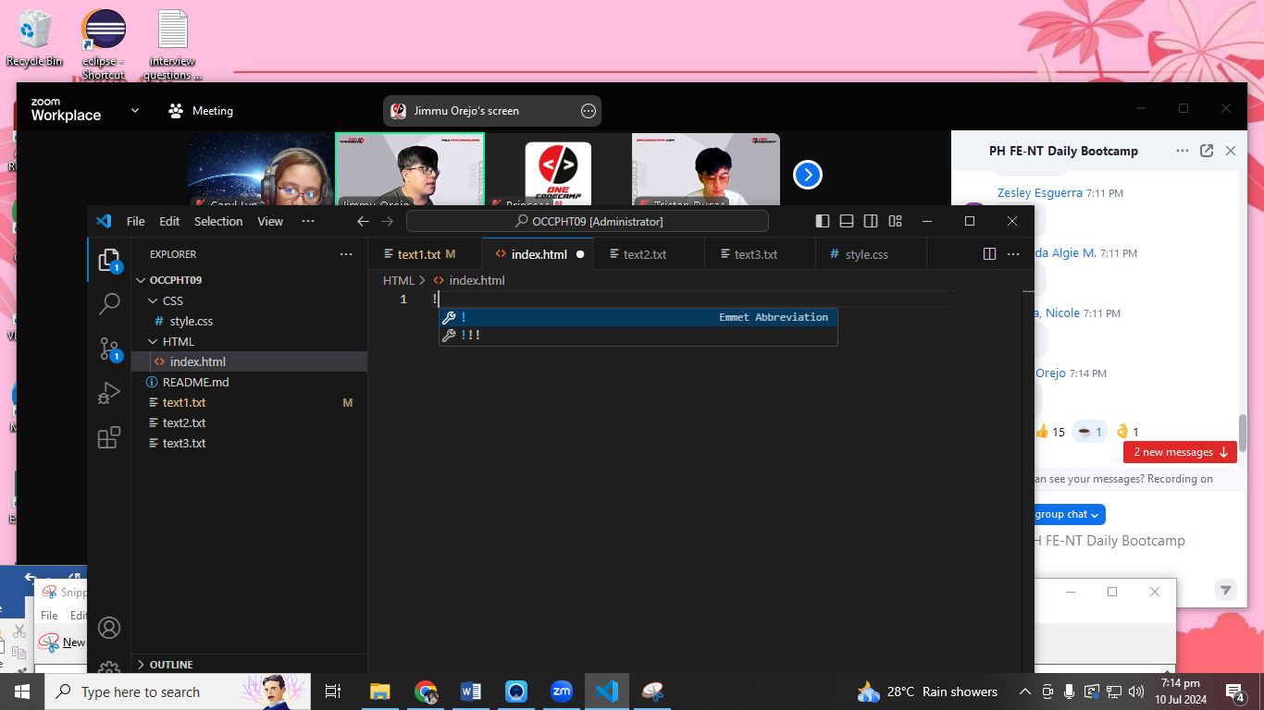

The Press Enter or Tab or Select with your mouse

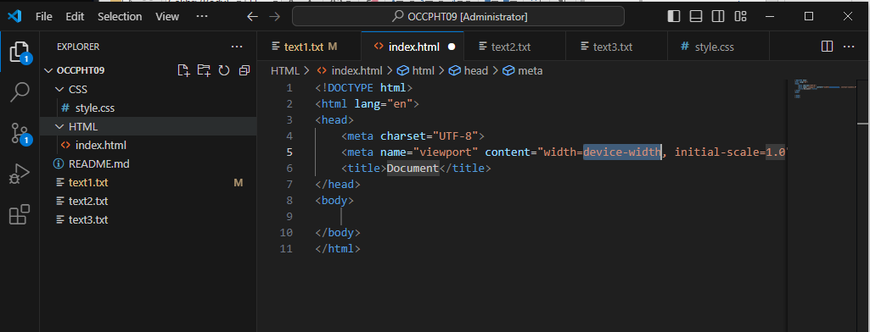

Semantics in order the search engine will find you quickly.

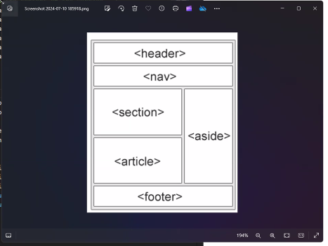

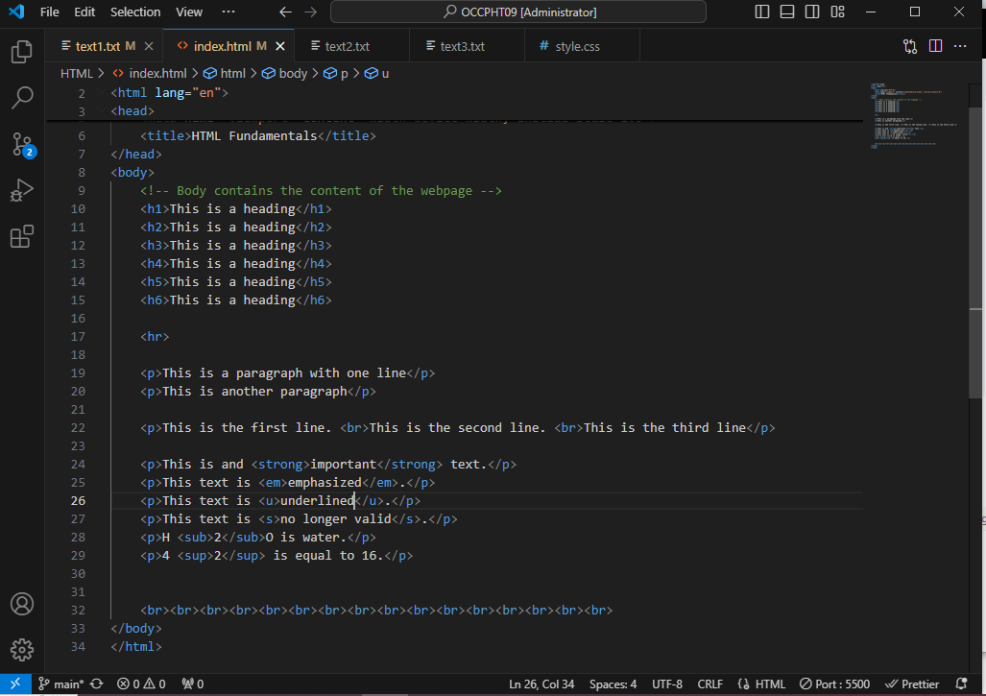

Example of sematics

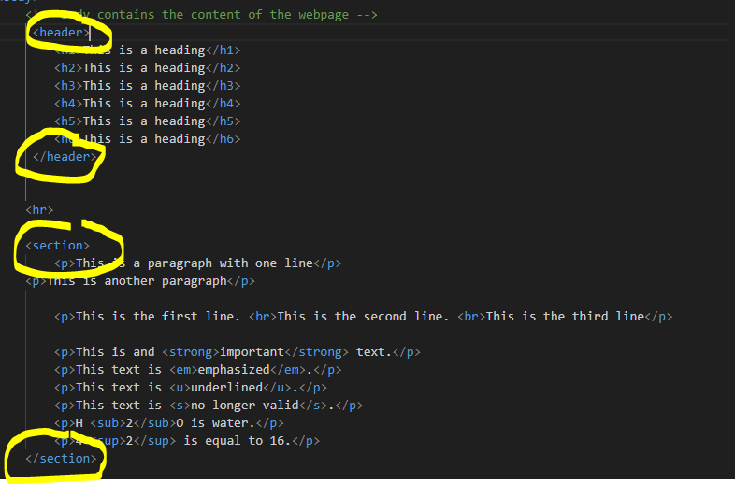

<section id="forms">  
        <!-- Usage of form elements: input, textarea, select, button -->  
        <form action="submit_page.php" method="post">  
            <h2>Form Example</h2>  
            <label for="name">Name:</label>  
            <input type="text" name="name" id="name" required />  
            <br>  
            <label for="hobbies">Hobbies:</label>  
            <textarea id="hobbies" name="hobbies" rows="2" cols="30" required></textarea>  
            <br>  
            <label for="gender">Gender:</label>  
            <select name="gender" id="gender" required>  
                <option value="male">Male</option>  
                <option value="female">Female</option>  
                <option value="Others">Others</option>  
            </select>  
            <br><br>

<!-- Radio buttons and checkboxes provide options for users to make selections -->  
            <input type="radio" name="options" id="option1" value="option1" required>  
            <label for="option1">Option1</label>  
            <input type="radio" name="options" id="option2" value="option2" required>  
            <label for="option2">Option2</label>  
              
            <br><br>  
            <input type="checkbox" name="check" id="check1" value="check1">  
            <label for="check1">Check1</label>  
            <input type="checkbox" name="check" id="check2" value="check2">  
            <label for="check2">Check2</label>  
            <br><br>  
            <button type="submit">Submit</button>  
        </form>  
    </section>

